

UID ASSIGNMENT

SUBMITTED BY
NAME | M . SAI KRISHNA.
ROLL NO | AV.SC.U4CSE25128
YEAR/SEM/SECTION | 1ST YEAR/ SEM-2/CSE-B
CREDITS | 03

SUBMITTED TO
NAME | DR. RAJ KUMAR BATCHU
DESIGNATION | ASST.PROFFESSOR (Sl. Grade)
DEPARTMENT | SCHOOL OF COMPUTING

AIM :
Create a similar website using the concepts of HTML , CSS , JAVASCRIPT.
(ABHIBUS)
CODE :

<!DOCTYPE html>
<html lang="en">
<head>
<meta charset="UTF-8">
<meta name="viewport" content="width=device-width, initial-scale=1.0">
<title>AbhiBus — Book Bus Tickets Online</title>
<link rel="preconnect" href="https://fonts.googleapis.com">
<link href="https://fonts.googleapis.com/css2?family=DM+Sans:wght@400;500;600&family=DM+Serif+Display&display=swap" rel="stylesheet">
<style>
*, *::before, *::after { box-sizing: border-box; margin: 0; padding: 0; }

:root {
--primary: #1565c0;
--primary-dark: #0d47a1;
--primary-light: #e3f2fd;
--accent: #ff6f00;
--accent-light: #fff8e1;
--green: #2e7d32;
--green-light: #e8f5e9;
--bg: #f0f4ff;
--white: #ffffff;
--text: #1a1a1a;
--text-sec: #555;
--text-muted: #999;
--border: #dde6f7;
--radius: 10px;
--radius-lg: 14px;
}

body {
font-family: 'DM Sans', sans-serif;
background: var(--bg);
color: var(--text);
font-size: 15px;
line-height: 1.5;
}

.header {
background: linear-gradient(90deg, var(--primary) 0%, #1976d2 100%);
padding: 0 24px;
height: 58px;
display: flex;
align-items: center;
gap: 20px;
position: sticky;
top: 0;
z-index: 100;
box-shadow: 0 2px 10px rgba(21,101,192,0.25);
}
.logo {
font-family: 'DM Serif Display', serif;
font-size: 23px;
color: #fff;
cursor: pointer;
display: flex;
align-items: center;
gap: 6px;
}
.logo-icon { font-size: 26px; }
.logo span { color: #ffd54f; }
.header-nav { margin-left: auto; display: flex; gap: 6px; align-items: center; }
.nav-btn {
background: transparent;
border: 1px solid rgba(255,255,255,0.4);
color: #fff;
padding: 6px 14px;
border-radius: 20px;
font-size: 13px;
cursor: pointer;
font-family: 'DM Sans', sans-serif;
transition: background 0.15s;
}
.nav-btn:hover, .nav-btn.active { background: rgba(255,255,255,0.22); }
.nav-btn.register-btn {
background: var(--accent);
border-color: var(--accent);
font-weight: 600;
}
.nav-btn.register-btn:hover { background: #e65100; border-color: #e65100; }

.page { display: none; }
.page.active { display: block; }

.hero {
background: linear-gradient(135deg, #0d47a1 0%, #1976d2 55%, #42a5f5 100%);
padding: 52px 24px 88px;
text-align: center;
position: relative;
overflow: hidden;
}
.hero::before {
content: '🚌';
position: absolute;
font-size: 180px;
right: -20px;
bottom: -30px;
opacity: 0.07;
transform: scaleX(-1);
}
.hero h1 {
font-family: 'DM Serif Display', serif;
font-size: 36px;
color: #fff;
margin-bottom: 8px;
}
.hero p { color: rgba(255,255,255,0.8); font-size: 15px; }

.search-wrapper {
max-width: 700px;
margin: -52px auto 0;
padding: 0 16px;
}
.search-card {
background: var(--white);
border-radius: var(--radius-lg);
box-shadow: 0 6px 28px rgba(21,101,192,0.15);
padding: 24px;
border-top: 4px solid var(--accent);
}
.search-row {
display: grid;
grid-template-columns: 1fr 44px 1fr;
gap: 10px;
align-items: flex-end;
margin-bottom: 14px;
}
.field-group { display: flex; flex-direction: column; gap: 5px; }
.field-group label {
font-size: 11px;
text-transform: uppercase;
letter-spacing: 0.6px;
color: var(--text-sec);
font-weight: 600;
}
.field-group input,
.field-group select {
border: 1.5px solid var(--border);
border-radius: var(--radius);
padding: 11px 14px;
font-size: 15px;
font-family: 'DM Sans', sans-serif;
color: var(--text);
background: #fff;
transition: border-color 0.15s;
outline: none;
width: 100%;
}
.field-group input:focus,
.field-group select:focus { border-color: var(--primary); }

.swap-btn {
background: var(--primary-light);
border: 1.5px solid var(--primary);
border-radius: 50%;
width: 44px;
height: 44px;
cursor: pointer;
color: var(--primary);
font-size: 20px;
display: flex;
align-items: center;
justify-content: center;
transition: background 0.15s, transform 0.2s;
}
.swap-btn:hover { background: var(--primary); color: #fff; transform: rotate(180deg); }

.bottom-row {
display: grid;
grid-template-columns: 1fr 1fr auto;
gap: 10px;
align-items: flex-end;
}
.search-btn {
background: linear-gradient(90deg, var(--accent), #ff8f00);
color: #fff;
border: none;
border-radius: var(--radius);
padding: 12px 28px;
font-size: 15px;
font-weight: 700;
font-family: 'DM Sans', sans-serif;
cursor: pointer;
display: flex;
align-items: center;
gap: 8px;
white-space: nowrap;
transition: opacity 0.15s, transform 0.1s;
box-shadow: 0 3px 10px rgba(255,111,0,0.35);
}
.search-btn:hover { opacity: 0.9; }
.search-btn:active { transform: scale(0.98); }

.perks {
display: flex;
gap: 24px;
justify-content: center;
flex-wrap: wrap;
padding: 32px 16px 16px;
}
.perk {
display: flex;
align-items: center;
gap: 8px;
font-size: 13px;
color: var(--text-sec);
}
.perk-icon {
width: 32px;
height: 32px;
background: var(--primary-light);
border-radius: 50%;
display: flex;
align-items: center;
justify-content: center;
font-size: 16px;
}

.results-bar {
background: linear-gradient(90deg, var(--primary) 0%, #1976d2 100%);
padding: 14px 24px;
display: flex;
align-items: center;
gap: 12px;
flex-wrap: wrap;
}
.results-bar strong { color: #fff; font-size: 16px; }
.results-bar span { color: rgba(255,255,255,0.75); font-size: 13px; }
.back-btn {
background: rgba(255,255,255,0.2);
border: none;
color: #fff;
padding: 5px 12px;
border-radius: 16px;
font-size: 13px;
cursor: pointer;
font-family: 'DM Sans', sans-serif;
margin-right: 8px;
}

.results-body { max-width: 780px; margin: 0 auto; padding: 20px 16px; }

.filters { display: flex; gap: 8px; margin-bottom: 18px; flex-wrap: wrap; }
.filter-pill {
border: 1.5px solid var(--border);
border-radius: 20px;
padding: 6px 16px;
font-size: 13px;
cursor: pointer;
background: var(--white);
color: var(--text);
font-family: 'DM Sans', sans-serif;
transition: all 0.15s;
}
.filter-pill.active { background: var(--primary); border-color: var(--primary); color: #fff; }
.filter-pill:hover:not(.active) { border-color: var(--primary); color: var(--primary); }

.bus-card {
background: var(--white);
border: 1.5px solid var(--border);
border-radius: var(--radius-lg);
padding: 18px 20px;
margin-bottom: 12px;
display: grid;
grid-template-columns: 1fr auto;
gap: 16px;
align-items: start;
transition: border-color 0.15s, box-shadow 0.15s;
cursor: pointer;
border-left: 4px solid transparent;
}
.bus-card:hover {
border-color: var(--primary);
border-left-color: var(--accent);
box-shadow: 0 2px 14px rgba(21,101,192,0.12);
}
.bus-name { font-size: 16px; font-weight: 700; margin-bottom: 3px; }
.bus-type { font-size: 12px; color: var(--text-sec); margin-bottom: 12px; }

.operator-badge {
display: inline-block;
font-size: 10px;
font-weight: 700;
padding: 2px 8px;
border-radius: 4px;
margin-bottom: 6px;
text-transform: uppercase;
letter-spacing: 0.4px;
}
.badge-govt { background: #e3f2fd; color: #1565c0; border: 1px solid #bbdefb; }
.badge-private { background: #fff8e1; color: #e65100; border: 1px solid #ffe0b2; }
.badge-premium { background: #f3e5f5; color: #7b1fa2; border: 1px solid #e1bee7; }

.timing { display: flex; align-items: center; gap: 12px; }
.t-time { font-size: 20px; font-weight: 700; }
.t-city { font-size: 11px; color: var(--text-muted); margin-top: 2px; }
.dur-line { display: flex; flex-direction: column; align-items: center; gap: 4px; flex: 1; max-width: 100px; }
.dur-bar { width: 100%; height: 1px; background: var(--border); position: relative; }
.dur-bar::before, .dur-bar::after {
content: '';
position: absolute;
top: 50%;
transform: translateY(-50%);
width: 5px; height: 5px;
border-radius: 50%;
background: var(--primary);
}
.dur-bar::before { left: 0; }
.dur-bar::after { right: 0; }
.dur-text { font-size: 11px; color: var(--text-sec); }

.amenity-row { display: flex; gap: 8px; margin-top: 10px; flex-wrap: wrap; }
.amenity { font-size: 11px; color: var(--text-sec); display: flex; align-items: center; gap: 4px; }

.rating-badge {
display: inline-flex;
align-items: center;
gap: 3px;
background: var(--green-light);
color: var(--green);
font-size: 11px;
font-weight: 600;
padding: 3px 8px;
border-radius: 5px;
margin-top: 8px;
}

.price-col { text-align: right; }
.price-from { font-size: 11px; color: var(--text-muted); }
.price-amt { font-size: 22px; font-weight: 800; color: var(--accent); margin: 3px 0; }
.seats-avail { font-size: 12px; font-weight: 500; margin-bottom: 10px; }
.seats-avail.low { color: #c62828; }
.seats-avail.ok { color: var(--green); }

.view-btn {
background: linear-gradient(90deg, var(--primary), #1976d2);
color: #fff;
border: none;
border-radius: var(--radius);
padding: 9px 20px;
font-size: 13px;
font-weight: 700;
font-family: 'DM Sans', sans-serif;
cursor: pointer;
transition: opacity 0.15s;
}
.view-btn:hover { opacity: 0.88; }

.seat-page-header {
background: linear-gradient(90deg, var(--primary), #1976d2);
padding: 14px 24px;
display: flex;
align-items: center;
gap: 12px;
flex-wrap: wrap;
}
.seat-page-header strong { color: #fff; }
.seat-page-header span { color: rgba(255,255,255,0.75); font-size: 13px; }

.seats-container { max-width: 780px; margin: 0 auto; padding: 20px 16px; }

.journey-bar {
background: var(--white);
border: 1.5px solid var(--border);
border-radius: var(--radius-lg);
padding: 16px 20px;
margin-bottom: 18px;
display: flex;
align-items: center;
justify-content: space-between;
flex-wrap: wrap;
gap: 10px;
border-left: 4px solid var(--accent);
}
.jb-route { font-size: 16px; font-weight: 700; margin-bottom: 4px; }
.jb-detail { font-size: 13px; color: var(--text-sec); }
.jb-price { font-size: 24px; font-weight: 800; color: var(--accent); }
.jb-price-label { font-size: 11px; color: var(--text-muted); text-align: right; }

.seat-layout-wrap {
display: grid;
grid-template-columns: 1fr 1fr;
gap: 14px;
}

.seat-deck {
background: var(--white);
border: 1.5px solid var(--border);
border-radius: var(--radius-lg);
padding: 18px;
}
.deck-label {
font-size: 11px;
font-weight: 700;
color: var(--primary);
text-transform: uppercase;
letter-spacing: 0.6px;
margin-bottom: 14px;
padding-bottom: 10px;
border-bottom: 1px solid var(--border);
}

.seat-grid {
display: grid;
grid-template-columns: repeat(5, 38px);
gap: 7px;
justify-content: center;
}
.seat {
width: 38px;
height: 38px;
border-radius: 7px;
border: 1.5px solid var(--border);
cursor: pointer;
display: flex;
align-items: center;
justify-content: center;
font-size: 11px;
font-weight: 600;
color: var(--text-sec);
background: var(--white);
transition: all 0.15s;
user-select: none;
}
.seat.available:hover { border-color: var(--primary); color: var(--primary); background: var(--primary-light); }
.seat.selected { background: var(--primary); border-color: var(--primary); color: #fff; }
.seat.booked { background: #f5f5f5; border-color: #e0e0e0; color: #ccc; cursor: not-allowed; }
.seat.ladies { background: #fce4ec; border-color: #f48fb1; color: #ad1457; }
.seat.ladies:hover { background: #f8bbd9; }
.aisle-gap { width: 38px; height: 38px; }

.legend { display: flex; gap: 14px; flex-wrap: wrap; margin-top: 14px; padding-top: 12px; border-top: 1px solid var(--border); }
.legend-item { display: flex; align-items: center; gap: 6px; font-size: 12px; color: var(--text-sec); }
.legend-box { width: 16px; height: 16px; border-radius: 4px; border: 1.5px solid var(--border); }
.legend-box.sel { background: var(--primary); border-color: var(--primary); }
.legend-box.bkd { background: #f5f5f5; }
.legend-box.ladies { background: #fce4ec; border-color: #f48fb1; }

/* Right panel */
.right-panel { display: flex; flex-direction: column; gap: 14px; }

.booking-summary {
background: var(--white);
border: 1.5px solid var(--border);
border-radius: var(--radius-lg);
padding: 18px;
border-top: 3px solid var(--primary);
}
.summary-title { font-size: 14px; font-weight: 700; color: var(--primary); margin-bottom: 14px; padding-bottom: 10px; border-bottom: 1px solid var(--border); }
.empty-sel { color: var(--text-muted); font-size: 13px; text-align: center; padding: 8px 0; }
.summary-row { display: flex; justify-content: space-between; font-size: 13px; padding: 5px 0; color: var(--text-sec); }
.summary-total {
display: flex;
justify-content: space-between;
font-size: 16px;
font-weight: 700;
padding-top: 10px;
margin-top: 6px;
border-top: 1.5px solid var(--border);
}

.proceed-btn {
width: 100%;
background: linear-gradient(90deg, var(--accent), #ff8f00);
color: #fff;
border: none;
border-radius: var(--radius);
padding: 14px;
font-size: 15px;
font-weight: 700;
font-family: 'DM Sans', sans-serif;
cursor: pointer;
margin-top: 14px;
transition: opacity 0.15s, transform 0.1s;
box-shadow: 0 3px 10px rgba(255,111,0,0.3);
}
.proceed-btn:hover:not(:disabled) { opacity: 0.9; }
.proceed-btn:active:not(:disabled) { transform: scale(0.99); }
.proceed-btn:disabled { opacity: 0.45; cursor: not-allowed; box-shadow: none; }

.stop-panel {
background: var(--white);
border: 1.5px solid var(--border);
border-radius: var(--radius-lg);
padding: 18px;
}
.stop-title { font-size: 13px; font-weight: 600; color: var(--primary); margin-bottom: 10px; }
.stop-panel select {
width: 100%;
font-size: 13px;
font-family: 'DM Sans', sans-serif;
border: 1.5px solid var(--border);
border-radius: var(--radius);
padding: 9px 12px;
background: #fff;
color: var(--text);
outline: none;
margin-bottom: 12px;
}
.stop-panel select:focus { border-color: var(--primary); }

.city-input-wrap { position: relative; }
.city-dropdown {
position: absolute;
top: calc(100% + 4px);
left: 0; right: 0;
background: #fff;
border: 1.5px solid var(--primary);
border-radius: var(--radius);
box-shadow: 0 8px 24px rgba(0,0,0,0.12);
z-index: 200;
max-height: 240px;
overflow-y: auto;
display: none;
}
.city-dropdown.open { display: block; }
.city-option {
padding: 10px 14px;
cursor: pointer;
font-size: 14px;
display: flex;
align-items: center;
gap: 8px;
color: var(--text);
border-bottom: 1px solid #f5f5f5;
transition: background 0.1s;
}
.city-option:last-child { border-bottom: none; }
.city-option:hover, .city-option.highlighted { background: var(--primary-light); color: var(--primary); }
.city-option .city-state { font-size: 11px; color: var(--text-muted); margin-left: auto; }
.city-option mark { background: none; color: var(--primary); font-weight: 700; }

.results-stats {
display: flex;
gap: 10px;
margin-left: auto;
align-items: center;
flex-wrap: wrap;
}
.stat-chip {
background: rgba(255,255,255,0.18);
border: 1px solid rgba(255,255,255,0.35);
color: #fff;
padding: 4px 12px;
border-radius: 20px;
font-size: 13px;
font-weight: 500;
display: flex;
align-items: center;
gap: 5px;
}
.stat-chip strong { font-weight: 700; }

.offers-section {
max-width: 700px;
margin: 28px auto 0;
padding: 0 16px;
}
.section-header {
display: flex;
align-items: center;
justify-content: space-between;
margin-bottom: 14px;
}
.section-title {
font-size: 18px;
font-weight: 700;
color: var(--text);
display: flex;
align-items: center;
gap: 8px;
}
.view-more {
font-size: 13px;
color: var(--primary);
cursor: pointer;
font-weight: 600;
text-decoration: none;
transition: opacity 0.15s;
}
.view-more:hover { opacity: 0.75; }

.offer-filters { display: flex; gap: 8px; margin-bottom: 14px; }
.offer-pill {
border: 1.5px solid var(--border);
border-radius: 20px;
padding: 5px 16px;
font-size: 13px;
cursor: pointer;
background: var(--white);
color: var(--text);
font-family: 'DM Sans', sans-serif;
transition: all 0.15s;
font-weight: 500;
}
.offer-pill.active { background: var(--primary); border-color: var(--primary); color: #fff; }
.offer-pill:hover:not(.active) { border-color: var(--primary); color: var(--primary); }

.offers-carousel-wrap { position: relative; }
.offers-track-outer { overflow: hidden; border-radius: var(--radius-lg); }
.offers-track {
display: flex;
gap: 14px;
transition: transform 0.35s ease;
}
.offer-card {
flex: 0 0 calc(50% - 7px);
border-radius: var(--radius-lg);
padding: 20px 20px 16px;
position: relative;
overflow: hidden;
min-height: 160px;
display: flex;
flex-direction: column;
justify-content: space-between;
cursor: pointer;
transition: transform 0.2s, box-shadow 0.2s;
}
.offer-card:hover { transform: translateY(-2px); box-shadow: 0 8px 24px rgba(0,0,0,0.14); }
.offer-card.peach { background: linear-gradient(135deg, #fff3e0 0%, #ffe0b2 100%); }
.offer-card.gold { background: linear-gradient(135deg, #fffde7 0%, #fff59d 100%); }
.offer-card.rose { background: linear-gradient(135deg, #fce4ec 0%, #f8bbd0 100%); }
.offer-card.mint { background: linear-gradient(135deg, #e8f5e9 0%, #c8e6c9 100%); }
.offer-card.sky { background: linear-gradient(135deg, #e3f2fd 0%, #bbdefb 100%); }
.offer-card.lilac { background: linear-gradient(135deg, #f3e5f5 0%, #e1bee7 100%); }

.offer-tag {
display: inline-flex;
align-items: center;
gap: 5px;
background: rgba(0,0,0,0.08);
border-radius: 6px;
padding: 3px 9px;
font-size: 11px;
font-weight: 600;
color: #444;
margin-bottom: 8px;
width: fit-content;
}
.offer-title {
font-size: 15px;
font-weight: 700;
color: #1a1a1a;
margin-bottom: 3px;
line-height: 1.3;
}
.offer-valid { font-size: 11px; color: #666; margin-bottom: 10px; }
.offer-code-row { display: flex; align-items: center; gap: 8px; margin-top: 6px; }
.offer-code {
display: flex;
align-items: center;
gap: 6px;
background: rgba(255,255,255,0.65);
border: 1.5px dashed rgba(0,0,0,0.2);
border-radius: 7px;
padding: 5px 10px;
font-size: 12px;
font-weight: 700;
color: var(--primary);
letter-spacing: 0.5px;
cursor: pointer;
transition: background 0.15s;
}
.offer-code:hover { background: rgba(255,255,255,0.9); }
.offer-copy-tip { font-size: 10px; color: #888; }
.offer-bus-img {
position: absolute;
bottom: 8px;
right: 8px;
font-size: 38px;
opacity: 0.18;
pointer-events: none;
transform: scaleX(-1);
}

.carousel-nav {
display: flex;
justify-content: flex-end;
gap: 8px;
margin-top: 10px;
align-items: center;
}
.cnav-btn {
width: 32px; height: 32px;
border-radius: 50%;
border: 1.5px solid var(--border);
background: #fff;
cursor: pointer;
font-size: 16px;
display: flex;
align-items: center;
justify-content: center;
transition: all 0.15s;
color: var(--text-sec);
}
.cnav-btn:hover { border-color: var(--primary); color: var(--primary); }
.cnav-btn:disabled { opacity: 0.3; cursor: not-allowed; }
.carousel-dots { display: flex; gap: 5px; margin-right: auto; align-items: center; }
.cdot {
width: 6px; height: 6px;
border-radius: 50%;
background: var(--border);
cursor: pointer;
transition: background 0.15s, width 0.2s;
}
.cdot.active { background: var(--primary); width: 16px; border-radius: 3px; }

.booking-card {
background: var(--white);
border: 1.5px solid var(--border);
border-radius: var(--radius-lg);
padding: 18px 20px;
margin-bottom: 12px;
transition: box-shadow 0.15s;
}
.booking-card:hover { box-shadow: 0 2px 12px rgba(0,0,0,0.08); }
.bk-top {
display: flex;
align-items: flex-start;
justify-content: space-between;
gap: 12px;
margin-bottom: 12px;
}
.bk-bus-name { font-size: 15px; font-weight: 700; margin-bottom: 2px; }
.bk-bus-type { font-size: 12px; color: var(--text-sec); }
.bk-status {
font-size: 11px;
font-weight: 700;
padding: 4px 10px;
border-radius: 20px;
white-space: nowrap;
flex-shrink: 0;
}
.bk-status.upcoming { background: #e3f2fd; color: #1565c0; }
.bk-status.completed { background: var(--green-light); color: var(--green); }
.bk-status.cancelled { background: #fce4ec; color: #c62828; }
.bk-route {
display: flex;
align-items: center;
gap: 10px;
padding: 10px 0;
border-top: 1px solid var(--border);
border-bottom: 1px solid var(--border);
margin-bottom: 12px;
}
.bk-city { flex: 1; }
.bk-city-name { font-size: 15px; font-weight: 700; }
.bk-city-time { font-size: 12px; color: var(--text-sec); margin-top: 1px; }
.bk-arrow { font-size: 18px; color: var(--primary); flex-shrink: 0; }
.bk-meta {
display: flex;
gap: 18px;
flex-wrap: wrap;
font-size: 12px;
color: var(--text-sec);
}
.bk-meta span { display: flex; align-items: center; gap: 4px; }
.bk-meta strong { color: var(--text); font-weight: 600; }
.bk-footer {
display: flex;
align-items: center;
justify-content: space-between;
margin-top: 14px;
padding-top: 12px;
border-top: 1px solid var(--border);
gap: 10px;
flex-wrap: wrap;
}
.bk-total { font-size: 17px; font-weight: 700; color: var(--accent); }
.bk-total-label { font-size: 11px; color: var(--text-muted); }
.bk-actions { display: flex; gap: 8px; }
.bk-btn {
border: 1.5px solid var(--border);
background: #fff;
border-radius: var(--radius);
padding: 7px 16px;
font-size: 12px;
font-weight: 600;
font-family: 'DM Sans', sans-serif;
cursor: pointer;
color: var(--text-sec);
transition: all 0.15s;
}
.bk-btn:hover { border-color: var(--primary); color: var(--primary); }
.bk-btn.primary { background: var(--primary); border-color: var(--primary); color: #fff; }
.bk-btn.primary:hover { background: var(--primary-dark); }
.bk-empty {
text-align: center;
padding: 48px 20px;
color: var(--text-muted);
}
.bk-empty-icon { font-size: 48px; margin-bottom: 12px; }
.bk-empty-title { font-size: 16px; font-weight: 600; color: var(--text-sec); margin-bottom: 6px; }
.bk-empty-sub { font-size: 13px; }

.register-hero {
background: linear-gradient(135deg, #0d47a1 0%, #1976d2 55%, #42a5f5 100%);
padding: 48px 24px 88px;
text-align: center;
}
.register-hero h1 {
font-family: 'DM Serif Display', serif;
font-size: 32px;
color: #fff;
margin-bottom: 8px;
}
.register-hero p { color: rgba(255,255,255,0.8); font-size: 15px; }

.register-wrapper {
max-width: 500px;
margin: -52px auto 40px;
padding: 0 16px;
}
.register-card {
background: var(--white);
border-radius: var(--radius-lg);
box-shadow: 0 6px 28px rgba(21,101,192,0.15);
padding: 32px 28px;
border-top: 4px solid var(--accent);
}
.register-card h2 {
font-size: 20px;
font-weight: 700;
margin-bottom: 6px;
color: var(--primary);
}
.register-card .sub { font-size: 13px; color: var(--text-sec); margin-bottom: 22px; }

.form-row { display: grid; grid-template-columns: 1fr 1fr; gap: 14px; }
.form-group { display: flex; flex-direction: column; gap: 5px; margin-bottom: 14px; }
.form-group label {
font-size: 12px;
font-weight: 600;
color: var(--text-sec);
text-transform: uppercase;
letter-spacing: 0.4px;
}
.form-group input,
.form-group select {
border: 1.5px solid var(--border);
border-radius: var(--radius);
padding: 11px 14px;
font-size: 14px;
font-family: 'DM Sans', sans-serif;
color: var(--text);
background: #fff;
transition: border-color 0.15s, box-shadow 0.15s;
outline: none;
width: 100%;
}
.form-group input:focus,
.form-group select:focus {
border-color: var(--primary);
box-shadow: 0 0 0 3px rgba(21,101,192,0.1);
}
.form-group input.error { border-color: #e53935; }
.form-error { font-size: 11px; color: #e53935; margin-top: 3px; display: none; }
.form-error.show { display: block; }

.password-wrap { position: relative; }
.toggle-pw {
position: absolute;
right: 12px;
top: 50%;
transform: translateY(-50%);
cursor: pointer;
font-size: 16px;
color: var(--text-muted);
user-select: none;
}

.terms-row {
display: flex;
align-items: flex-start;
gap: 10px;
margin-bottom: 18px;
font-size: 13px;
color: var(--text-sec);
}
.terms-row input[type="checkbox"] {
width: 16px; height: 16px;
margin-top: 2px;
accent-color: var(--primary);
flex-shrink: 0;
}
.terms-row a { color: var(--primary); font-weight: 600; text-decoration: none; }
.terms-row a:hover { text-decoration: underline; }

.register-submit {
width: 100%;
background: linear-gradient(90deg, var(--accent), #ff8f00);
color: #fff;
border: none;
border-radius: var(--radius);
padding: 14px;
font-size: 16px;
font-weight: 700;
font-family: 'DM Sans', sans-serif;
cursor: pointer;
transition: opacity 0.15s, transform 0.1s;
box-shadow: 0 3px 10px rgba(255,111,0,0.3);
margin-bottom: 16px;
}
.register-submit:hover { opacity: 0.9; }
.register-submit:active { transform: scale(0.99); }

.login-link {
text-align: center;
font-size: 13px;
color: var(--text-sec);
padding-top: 14px;
border-top: 1px solid var(--border);
}
.login-link a { color: var(--primary); font-weight: 700; cursor: pointer; }
.login-link a:hover { text-decoration: underline; }

.social-divider {
display: flex;
align-items: center;
gap: 10px;
margin: 18px 0;
color: var(--text-muted);
font-size: 12px;
}
.social-divider::before, .social-divider::after {
content: '';
flex: 1;
height: 1px;
background: var(--border);
}
.social-btns { display: flex; gap: 10px; margin-bottom: 18px; }
.social-btn {
flex: 1;
display: flex;
align-items: center;
justify-content: center;
gap: 8px;
border: 1.5px solid var(--border);
border-radius: var(--radius);
padding: 10px;
font-size: 13px;
font-weight: 600;
font-family: 'DM Sans', sans-serif;
cursor: pointer;
background: #fff;
color: var(--text);
transition: border-color 0.15s, background 0.15s;
}
.social-btn:hover { border-color: var(--primary); background: var(--primary-light); }

.success-banner {
background: var(--green-light);
border: 1.5px solid #a5d6a7;
border-radius: var(--radius);
padding: 14px 18px;
display: none;
align-items: center;
gap: 10px;
margin-bottom: 18px;
font-size: 14px;
color: var(--green);
font-weight: 600;
}
.success-banner.show { display: flex; }

.strength-bar-wrap { margin-top: 6px; }
.strength-bar {
height: 4px;
border-radius: 2px;
background: var(--border);
overflow: hidden;
margin-bottom: 3px;
}
.strength-fill {
height: 100%;
border-radius: 2px;
transition: width 0.3s, background 0.3s;
width: 0%;
}
.strength-label { font-size: 11px; color: var(--text-muted); }

@media (max-width: 560px) {
.search-row { grid-template-columns: 1fr; }
.swap-btn { display: none; }
.bottom-row { grid-template-columns: 1fr; }
.seat-layout-wrap { grid-template-columns: 1fr; }
.hero h1 { font-size: 26px; }
.offer-card { flex: 0 0 calc(85% - 7px); }
.form-row { grid-template-columns: 1fr; }
}
</style>
</head>
<body>

<header class="header">
<div class="logo" onclick="showPage('search')">
<span class="logo-icon">🚌</span>Abhi<span>Bus</span>
</div>
<nav class="header-nav">
<button class="nav-btn active" id="nav-search" onclick="showPage('search')">Home</button>
<button class="nav-btn" id="nav-bookings" onclick="showPage('bookings')">My Bookings</button>
<button class="nav-btn register-btn" id="nav-register" onclick="showPage('register')">Register</button>
</nav>
</header>

<div id="page-search" class="page active">
<div class="hero">
<h1>Book Bus Tickets Online</h1>
<p>India's most trusted bus booking platform — 40,000+ routes</p>
</div>
<div class="search-wrapper">
<div class="search-card">
<div class="search-row">
<div class="field-group">
<label>From</label>
<div class="city-input-wrap">
<input type="text" id="from-city" value="Hyderabad" placeholder="Enter departure city" autocomplete="off" oninput="filterCities('from-city','from-dropdown')" onfocus="filterCities('from-city','from-dropdown')" onblur="closeDrop('from-dropdown')">
<div class="city-dropdown" id="from-dropdown"></div>
</div>
</div>
<button class="swap-btn" onclick="swapCities()" title="Swap">⇄</button>
<div class="field-group">
<label>To</label>
<div class="city-input-wrap">
<input type="text" id="to-city" value="Bengaluru" placeholder="Enter destination city" autocomplete="off" oninput="filterCities('to-city','to-dropdown')" onfocus="filterCities('to-city','to-dropdown')" onblur="closeDrop('to-dropdown')">
<div class="city-dropdown" id="to-dropdown"></div>
</div>
</div>
</div>
<div class="bottom-row">
<div class="field-group">
<label>Date of Journey</label>
<input type="date" id="journey-date">
</div>
<div class="field-group">
<label>Passengers</label>
<select>
<option>1 Passenger</option>
<option>2 Passengers</option>
<option>3 Passengers</option>
<option>4 Passengers</option>
<option>5 Passengers</option>
<option>6 Passengers</option>
</select>
</div>
<button class="search-btn" onclick="goToResults()">
<svg width="16" height="16" fill="none" stroke="currentColor" stroke-width="2.5" viewBox="0 0 24 24"><circle cx="11" cy="11" r="8"/><path d="m21 21-4.35-4.35"/></svg>
Search Buses
</button>
</div>
</div>
</div>
<div class="perks">
<div class="perk"><div class="perk-icon">🛡️</div>Safe &amp; secure payments</div>
<div class="perk"><div class="perk-icon">🎫</div>Instant confirmation</div>
<div class="perk"><div class="perk-icon">🎧</div>24/7 customer support</div>
<div class="perk"><div class="perk-icon">🔄</div>Easy cancellation</div>
<div class="perk"><div class="perk-icon">🏆</div>2 crore+ happy travellers</div>
</div>

<div class="offers-section">
<div class="section-header">
<div class="section-title">🏷️ Exclusive Offers</div>
<a class="view-more" href="#">View more →</a>
</div>
<div class="offer-filters">
<button class="offer-pill active" onclick="filterOffers('all',this)">All</button>
<button class="offer-pill" onclick="filterOffers('bus',this)">Bus</button>
</div>
<div class="offers-carousel-wrap">
<div class="offers-track-outer">
<div class="offers-track" id="offers-track"></div>
</div>
<div class="carousel-nav">
<div class="carousel-dots" id="carousel-dots"></div>
<button class="cnav-btn" id="prev-btn" onclick="scrollOffers(-1)" disabled>‹</button>
<button class="cnav-btn" id="next-btn" onclick="scrollOffers(1)">›</button>
</div>
</div>
</div>
</div>

<div id="page-results" class="page">
<div class="results-bar">
<button class="back-btn" onclick="showPage('search')">← Back</button>
<strong id="results-route">Hyderabad → Bengaluru</strong>
<span id="results-date">Today</span>
<div class="results-stats">
<div class="stat-chip">🚌 <strong id="bus-count">15</strong> buses</div>
</div>
</div>
<div class="results-body">
<div class="filters">
<div class="filter-pill active" onclick="filterBuses('all',this)">All</div>
<div class="filter-pill" onclick="filterBuses('ac',this)">AC</div>
<div class="filter-pill" onclick="filterBuses('non-ac',this)">Non-AC</div>
<div class="filter-pill" onclick="filterBuses('sleeper',this)">Sleeper</div>
<div class="filter-pill" onclick="filterBuses('seater',this)">Seater</div>
<div class="filter-pill" onclick="filterBuses('govt',this)">Govt Buses</div>
<div class="filter-pill" onclick="filterBuses('night',this)">Night</div>
</div>
<div id="bus-list"></div>
</div>
</div>

<div id="page-seats" class="page">
<div class="seat-page-header">
<button class="back-btn" onclick="showPage('results')">← Back</button>
<strong id="seat-header-name">APSRTC Garuda Plus</strong>
<span id="seat-header-detail">Hyderabad → Bengaluru · 21:00 → 06:30</span>
</div>
<div class="seats-container">
<div class="journey-bar">
<div>
<div class="jb-route" id="jb-name">APSRTC Garuda Plus</div>
<div class="jb-detail" id="jb-detail">Hyderabad → Bengaluru &nbsp;·&nbsp; 21:00 → 06:30 &nbsp;·&nbsp; <span style="color:var(--accent)">9h 30m</span></div>
</div>
<div style="text-align:right">
<div class="jb-price" id="jb-price">₹1299</div>
<div class="jb-price-label">per seat onwards</div>
</div>
</div>

<div class="seat-layout-wrap">
<div>
<div class="seat-deck">
<div class="deck-label">🪑 Lower Deck (40 seats)</div>
<div class="seat-grid" id="lower-deck"></div>
</div>
<div class="seat-deck" style="margin-top:14px">
<div class="deck-label">🛏️ Upper Deck (40 seats)</div>
<div class="seat-grid" id="upper-deck"></div>
</div>
<div class="legend">
<div class="legend-item"><div class="legend-box"></div>Available</div>
<div class="legend-item"><div class="legend-box sel"></div>Selected</div>
<div class="legend-item"><div class="legend-box bkd"></div>Booked</div>
<div class="legend-item"><div class="legend-box ladies"></div>Ladies only</div>
</div>
</div>

<div class="right-panel">
<div class="booking-summary">
<div class="summary-title">📋 Booking Summary</div>
<div id="empty-msg" class="empty-sel">No seats selected yet.<br>Click a seat to select.</div>
<div id="summary-details" style="display:none">
<div class="summary-row"><span>Selected seats</span><span id="sum-seats" style="font-weight:600;color:var(--text)">—</span></div>
<div class="summary-row"><span>Seat fare</span><span id="sum-fare">₹0</span></div>
<div class="summary-row"><span>Convenience fee (2%)</span><span id="sum-fee">₹0</span></div>
<div class="summary-total"><span>Total</span><span id="sum-total" style="color:var(--accent)">₹0</span></div>
</div>
<button class="proceed-btn" id="proceed-btn" disabled onclick="handleProceed()">
Select seats to proceed
</button>
</div>

<div class="stop-panel">
<div class="stop-title">🚏 Boarding Point</div>
<select id="boarding-select">
<option>Mehdipatnam Bus Stop — 20:45</option>
<option>Miyapur MMTS — 21:15</option>
<option>MGBS Imlibun — 21:00</option>
<option>Uppal — 20:30</option>
<option>LB Nagar — 20:20</option>
<option>Secunderabad — 21:10</option>
</select>
<div class="stop-title">📍 Dropping Point</div>
<select id="dropping-select">
<option>Majestic Bus Stand — 06:30</option>
<option>Silk Board — 06:00</option>
<option>Electronic City — 05:45</option>
<option>Hebbal — 06:15</option>
<option>Whitefield — 06:45</option>
<option>KR Puram — 06:10</option>
</select>
</div>
</div>
</div>
</div>
</div>

<div id="page-bookings" class="page">
<div class="results-bar">
<button class="back-btn" onclick="showPage('search')">← Back</button>
<strong>My Bookings</strong>
</div>
<div class="results-body">
<div class="filters" style="margin-bottom:18px;">
<div class="filter-pill active" id="bk-all" onclick="filterBookings('all',this)">All</div>
<div class="filter-pill" id="bk-upcoming" onclick="filterBookings('upcoming',this)">Upcoming</div>
<div class="filter-pill" id="bk-completed" onclick="filterBookings('completed',this)">Completed</div>
<div class="filter-pill" id="bk-cancelled" onclick="filterBookings('cancelled',this)">Cancelled</div>
</div>
<div id="bookings-list"></div>
</div>
</div>

<div id="page-register" class="page">
<div class="register-hero">
<h1>Create Your Account</h1>
<p>Join 2 crore+ happy travellers on AbhiBus</p>
</div>
<div class="register-wrapper">
<div class="register-card">
<h2>✨ Get Started Free</h2>
<p class="sub">Register to track bookings, get exclusive deals, and enjoy faster checkout.</p>

<div class="success-banner" id="reg-success">
✅ Account created successfully! Welcome to AbhiBus 🎉
</div>

<div class="social-btns">
<button class="social-btn" onclick="alert('Google sign-up (demo)')">
<svg width="16" height="16" viewBox="0 0 48 48"><path fill="#EA4335" d="M24 9.5c3.54 0 6.71 1.22 9.21 3.6l6.85-6.85C35.9 2.38 30.47 0 24 0 14.62 0 6.51 5.38 2.56 13.22l7.98 6.19C12.43 13.72 17.74 9.5 24 9.5z"/><path fill="#4285F4" d="M46.98 24.55c0-1.57-.15-3.09-.38-4.55H24v9.02h12.94c-.58 2.96-2.26 5.48-4.78 7.18l7.73 6c4.51-4.18 7.09-10.36 7.09-17.65z"/><path fill="#FBBC05" d="M10.53 28.59c-.48-1.45-.76-2.99-.76-4.59s.27-3.14.76-4.59l-7.98-6.19C.92 16.46 0 20.12 0 24c0 3.88.92 7.54 2.56 10.78l7.97-6.19z"/><path fill="#34A853" d="M24 48c6.48 0 11.93-2.13 15.89-5.81l-7.73-6c-2.15 1.45-4.92 2.3-8.16 2.3-6.26 0-11.57-4.22-13.47-9.91l-7.98 6.19C6.51 42.62 14.62 48 24 48z"/></svg>
Google
</button>
<button class="social-btn" onclick="alert('Facebook sign-up (demo)')">
<svg width="16" height="16" viewBox="0 0 24 24" fill="#1877F2"><path d="M24 12.073C24 5.405 18.627 0 12 0S0 5.405 0 12.073C0 18.1 4.388 23.094 10.125 24v-8.437H7.078v-3.49h3.047V9.413c0-3.007 1.792-4.669 4.533-4.669 1.312 0 2.686.235 2.686.235v2.953H15.83c-1.491 0-1.956.925-1.956 1.874v2.25h3.328l-.532 3.49h-2.796V24C19.612 23.094 24 18.1 24 12.073z"/></svg>
Facebook
</button>
</div>

<div class="social-divider">or register with email</div>

<div class="form-row">
<div class="form-group">
<label>First Name</label>
<input type="text" id="reg-fname" placeholder="Abhi">
<div class="form-error" id="err-fname">Please enter your first name</div>
</div>
<div class="form-group">
<label>Last Name</label>
<input type="text" id="reg-lname" placeholder="Kumar">
<div class="form-error" id="err-lname">Please enter your last name</div>
</div>
</div>

<div class="form-group">
<label>Email Address</label>
<input type="email" id="reg-email" placeholder="abhi@example.com">
<div class="form-error" id="err-email">Please enter a valid email</div>
</div>

<div class="form-group">
<label>Mobile Number</label>
<input type="tel" id="reg-phone" placeholder="+91 98765 43210" maxlength="13">
<div class="form-error" id="err-phone">Please enter a valid 10-digit mobile number</div>
</div>

<div class="form-row">
<div class="form-group">
<label>City</label>
<input type="text" id="reg-city" placeholder="Hyderabad">
</div>
<div class="form-group">
<label>State</label>
<select id="reg-state">
<option value="">Select state</option>
<option>Telangana</option>
<option>Andhra Pradesh</option>
<option>Karnataka</option>
<option>Tamil Nadu</option>
<option>Maharashtra</option>
<option>Kerala</option>
<option>Delhi</option>
<option>Gujarat</option>
<option>Rajasthan</option>
<option>Uttar Pradesh</option>
<option>West Bengal</option>
<option>Other</option>
</select>
</div>
</div>

<div class="form-group">
<label>Password</label>
<div class="password-wrap">
<input type="password" id="reg-pw" placeholder="Min. 8 characters" oninput="checkStrength(this.value)">
<span class="toggle-pw" onclick="togglePw('reg-pw',this)">👁️</span>
</div>
<div class="strength-bar-wrap">
<div class="strength-bar"><div class="strength-fill" id="str-fill"></div></div>
<div class="strength-label" id="str-label">Enter a password</div>
</div>
<div class="form-error" id="err-pw">Password must be at least 8 characters</div>
</div>

<div class="form-group">
<label>Confirm Password</label>
<div class="password-wrap">
<input type="password" id="reg-pw2" placeholder="Re-enter password">
<span class="toggle-pw" onclick="togglePw('reg-pw2',this)">👁️</span>
</div>
<div class="form-error" id="err-pw2">Passwords do not match</div>
</div>

<div class="terms-row">
<input type="checkbox" id="reg-terms">
<label for="reg-terms">
I agree to the <a href="#">Terms of Service</a> and <a href="#">Privacy Policy</a> of AbhiBus. I also agree to receive booking updates and offers via SMS and email.
</label>
</div>

<button class="register-submit" onclick="submitRegister()">🚀 Create My Account</button>

<div class="login-link">
Already have an account? <a onclick="alert('Login page coming soon!')">Sign in here →</a>
</div>
</div>
</div>
</div>

<script>

const CITIES = [
{ name: 'Hyderabad', state: 'Telangana' },
{ name: 'Bengaluru', state: 'Karnataka' },
{ name: 'Mumbai', state: 'Maharashtra' },
{ name: 'Chennai', state: 'Tamil Nadu' },
{ name: 'Delhi', state: 'Delhi' },
{ name: 'Pune', state: 'Maharashtra' },
{ name: 'Kolkata', state: 'West Bengal' },
{ name: 'Ahmedabad', state: 'Gujarat' },
{ name: 'Jaipur', state: 'Rajasthan' },
{ name: 'Surat', state: 'Gujarat' },
{ name: 'Lucknow', state: 'Uttar Pradesh' },
{ name: 'Nagpur', state: 'Maharashtra' },
{ name: 'Visakhapatnam', state: 'Andhra Pradesh' },
{ name: 'Vijayawada', state: 'Andhra Pradesh' },
{ name: 'Tirupati', state: 'Andhra Pradesh' },
{ name: 'Warangal', state: 'Telangana' },
{ name: 'Mysuru', state: 'Karnataka' },
{ name: 'Mangaluru', state: 'Karnataka' },
{ name: 'Coimbatore', state: 'Tamil Nadu' },
{ name: 'Madurai', state: 'Tamil Nadu' },
{ name: 'Trichy', state: 'Tamil Nadu' },
{ name: 'Salem', state: 'Tamil Nadu' },
{ name: 'Indore', state: 'Madhya Pradesh' },
{ name: 'Bhopal', state: 'Madhya Pradesh' },
{ name: 'Nashik', state: 'Maharashtra' },
{ name: 'Aurangabad', state: 'Maharashtra' },
{ name: 'Kolhapur', state: 'Maharashtra' },
{ name: 'Goa (Panaji)', state: 'Goa' },
{ name: 'Kochi', state: 'Kerala' },
{ name: 'Thiruvananthapuram', state: 'Kerala' },
{ name: 'Kozhikode', state: 'Kerala' },
{ name: 'Bhubaneswar', state: 'Odisha' },
{ name: 'Patna', state: 'Bihar' },
{ name: 'Raipur', state: 'Chhattisgarh' },
{ name: 'Chandigarh', state: 'Punjab' },
{ name: 'Amritsar', state: 'Punjab' },
{ name: 'Dehradun', state: 'Uttarakhand' },
{ name: 'Agra', state: 'Uttar Pradesh' },
{ name: 'Varanasi', state: 'Uttar Pradesh' },
{ name: 'Shimla', state: 'Himachal Pradesh' },
{ name: 'Nellore', state: 'Andhra Pradesh' },
{ name: 'Kurnool', state: 'Andhra Pradesh' },
{ name: 'Karimnagar', state: 'Telangana' },
{ name: 'Nizamabad', state: 'Telangana' },
];

const OFFERS = [
{ cat:'bus', theme:'peach', title:'Save up to ₹300 on bus tickets', valid:'Valid till 30 Jun', code:'ABHI300', desc:'For first-time users on AbhiBus' },
{ cat:'bus', theme:'gold', title:'Save up to ₹250 on APSRTC buses', valid:'Valid till 30 Jun', code:'APSRTC250', desc:'Exclusive for Andhra & Telangana routes' },
{ cat:'bus', theme:'rose', title:'Save up to ₹400 on AC Sleeper', valid:'Valid till 30 Jun', code:'SLEEPER400', desc:'Monsoon Special — limited time!' },
{ cat:'bus', theme:'mint', title:'Save up to ₹150 on TSRTC routes', valid:'Valid till 30 Jun', code:'TSRTC150', desc:'All TSRTC Garuda & Pushpak buses' },
{ cat:'bus', theme:'sky', title:'₹600 cashback on Orange Travels', valid:'Valid till 5 Jul', code:'ORANGE600', desc:'Minimum booking of ₹1500' },
{ cat:'bus', theme:'lilac', title:'Flat ₹200 off on Kaveri Express', valid:'Valid till 15 Jul', code:'KAVERI200', desc:'All Kaveri Express night routes' },
];

const buses = [

{ name:'APSRTC Garuda Plus', type:'AC Sleeper (2+1)', tags:['ac','sleeper','night','govt'], dep:'20:30', arr:'06:00', dur:'9h 30m', price:1299, seats:18, rating:4.6, amenities:['WiFi','USB','Water','Blanket'], operatorType:'govt' },
{ name:'APSRTC Indra AC Express', type:'AC Seater (2+2)', tags:['ac','seater','night','govt'], dep:'22:00', arr:'07:45', dur:'9h 45m', price:999, seats:28, rating:4.4, amenities:['USB','Water'], operatorType:'govt' },
{ name:'APSRTC Rajdhani Express', type:'AC Sleeper (2+1)', tags:['ac','sleeper','night','govt'], dep:'21:30', arr:'07:15', dur:'9h 45m', price:1499, seats:7, rating:4.7, amenities:['WiFi','USB','Water','Blanket'], operatorType:'govt' },

{ name:'TSRTC Garuda Plus', type:'AC Sleeper (2+1)', tags:['ac','sleeper','night','govt'], dep:'21:00', arr:'06:30', dur:'9h 30m', price:1199, seats:14, rating:4.5, amenities:['WiFi','USB','Water','Blanket'], operatorType:'govt' },
{ name:'TSRTC Pushpak Deluxe', type:'Non-AC Seater (2+2)', tags:['non-ac','seater','govt'], dep:'18:30', arr:'05:00', dur:'10h 30m', price:599, seats:32, rating:4.0, amenities:['Water'], operatorType:'govt' },
{ name:'TSRTC Express AC', type:'AC Seater (2+2)', tags:['ac','seater','night','govt'], dep:'23:15', arr:'09:00', dur:'9h 45m', price:849, seats:22, rating:4.2, amenities:['USB','Water'], operatorType:'govt' },

{ name:'Kaveri Express Gold', type:'AC Sleeper (2+1)', tags:['ac','sleeper','night'], dep:'20:00', arr:'05:30', dur:'9h 30m', price:1350, seats:10, rating:4.5, amenities:['WiFi','USB','Water','Blanket'], operatorType:'premium' },
{ name:'Kaveri Super Deluxe', type:'Volvo Multi-Axle (2+2)', tags:['ac','seater','night'], dep:'22:30', arr:'08:00', dur:'9h 30m', price:1100, seats:20, rating:4.3, amenities:['WiFi','USB','Water'], operatorType:'premium' },
{ name:'Kaveri Night Rider', type:'Non-AC Sleeper (2+1)', tags:['non-ac','sleeper','night'], dep:'21:00', arr:'07:30', dur:'10h 30m', price:699, seats:16, rating:3.9, amenities:['Water'], operatorType:'private' },

{ name:'Orange Travels Volvo AC', type:'Volvo Multi-Axle (2+2)', tags:['ac','seater','night'], dep:'19:45', arr:'05:15', dur:'9h 30m', price:1599, seats:24, rating:4.7, amenities:['WiFi','USB','Water','Blanket'], operatorType:'premium' },
{ name:'Orange Super Sleeper', type:'AC Sleeper (2+1)', tags:['ac','sleeper','night'], dep:'21:15', arr:'07:00', dur:'9h 45m', price:1799, seats:5, rating:4.8, amenities:['WiFi','USB','Water','Blanket'], operatorType:'premium' },
{ name:'Orange Semi-Sleeper', type:'AC Seater/Sleeper', tags:['ac','seater','sleeper','night'], dep:'23:00', arr:'08:45', dur:'9h 45m', price:1299, seats:12, rating:4.4, amenities:['USB','Water','Blanket'], operatorType:'premium' },

{ name:'VRL Travels AC Sleeper', type:'AC Sleeper (2+1)', tags:['ac','sleeper','night'], dep:'20:45', arr:'06:15', dur:'9h 30m', price:1150, seats:8, rating:4.3, amenities:['USB','Water','Blanket'], operatorType:'private' },
{ name:'SRS Travels Volvo', type:'Volvo B9R AC (2+2)', tags:['ac','seater','night'], dep:'22:00', arr:'07:30', dur:'9h 30m', price:1050, seats:3, rating:4.1, amenities:['USB','Water'], operatorType:'private' },
{ name:'Chartered Speed Premium', type:'AC Sleeper (2+1)', tags:['ac','sleeper','night'], dep:'19:00', arr:'04:30', dur:'9h 30m', price:1650, seats:15, rating:4.6, amenities:['WiFi','USB','Water','Blanket'], operatorType:'premium' },
];

const amenityEmoji = { WiFi:'📶', USB:'🔌', Water:'💧', Blanket:'🛏️' };
const operatorLabels = { govt:'Govt Bus', private:'Private', premium:'Premium' };
const operatorBadgeClass = { govt:'badge-govt', private:'badge-private', premium:'badge-premium' };

let activeFilter = 'all';
let selectedSeats = [];
let seatPriceMap = {};
let currentBusPrice = 1299;
let currentBusIdx = 0;
let offerFilter = 'all';
let carouselIdx = 0;

let dropCloseTimer = null;
function filterCities(inputId, dropId) {
clearTimeout(dropCloseTimer);
const val = document.getElementById(inputId).value.toLowerCase();
const drop = document.getElementById(dropId);
const matches = CITIES.filter(c => c.name.toLowerCase().includes(val)).slice(0, 10);
if (!matches.length) { drop.classList.remove('open'); return; }
drop.innerHTML = matches.map(c => {
const highlighted = c.name.replace(new RegExp(`(${val})`, 'gi'), '<mark>$1</mark>');
return `<div class="city-option" onmousedown="pickCity('${inputId}','${dropId}','${c.name}')">
<span>📍</span><span>${highlighted}</span><span class="city-state">${c.state}</span>
</div>`;
}).join('');
drop.classList.add('open');
}
function closeDrop(dropId) {
dropCloseTimer = setTimeout(() => {
document.getElementById(dropId).classList.remove('open');
}, 180);
}
function pickCity(inputId, dropId, name) {
document.getElementById(inputId).value = name;
document.getElementById(dropId).classList.remove('open');
}

function renderOffers(filter) {
offerFilter = filter;
const track = document.getElementById('offers-track');
const visible = filter === 'all' ? OFFERS : OFFERS.filter(o => o.cat === filter);
track.innerHTML = visible.map((o) => `
<div class="offer-card ${o.theme}">
<div>
<div class="offer-tag">🚌 ${o.cat.charAt(0).toUpperCase()+o.cat.slice(1)}</div>
<div class="offer-title">${o.title}</div>
<div class="offer-valid">${o.valid}</div>
<div style="font-size:12px;color:#555;margin-bottom:6px;">${o.desc}</div>
</div>
<div class="offer-code-row">
<div class="offer-code" onclick="copyCode('${o.code}',this)">🏷️ ${o.code}</div>
<span class="offer-copy-tip">tap to copy</span>
</div>
<div class="offer-bus-img">🚌</div>
</div>`).join('');
carouselIdx = 0;
track.style.transform = 'translateX(0)';
renderDots(visible.length);
updateNavBtns(visible.length);
}

function filterOffers(filter, el) {
document.querySelectorAll('.offer-pill').forEach(p => p.classList.remove('active'));
el.classList.add('active');
renderOffers(filter);
}

function copyCode(code, el) {
navigator.clipboard.writeText(code).catch(()=>{});
const orig = el.innerHTML;
el.innerHTML = '✅ Copied!';
el.style.color = 'var(--green)';
setTimeout(() => { el.innerHTML = orig; el.style.color = ''; }, 1500);
}

function getCardsPerView() { return window.innerWidth < 560 ? 1 : 2; }

function scrollOffers(dir) {
const track = document.getElementById('offers-track');
const perView = getCardsPerView();
const count = (offerFilter === 'all' ? OFFERS : OFFERS.filter(o => o.cat === offerFilter)).length;
const maxIdx = Math.ceil(count / perView) - 1;
carouselIdx = Math.max(0, Math.min(maxIdx, carouselIdx + dir));
const cardW = track.querySelector('.offer-card')?.offsetWidth || 0;
const gap = 14;
track.style.transform = `translateX(-${carouselIdx * (cardW * perView + gap * perView)}px)`;
updateNavBtns(count);
renderDots(count);
}

function renderDots(count) {
const perView = getCardsPerView();
const pages = Math.ceil(count / perView);
const dotsEl = document.getElementById('carousel-dots');
dotsEl.innerHTML = Array.from({length: pages}, (_, i) =>
`<div class="cdot ${i === carouselIdx ? 'active' : ''}" onclick="goToPage(${i})"></div>`
).join('');
}

function goToPage(idx) {
const filter = offerFilter;
const count = (filter === 'all' ? OFFERS : OFFERS.filter(o => o.cat === filter)).length;
carouselIdx = idx;
const track = document.getElementById('offers-track');
const perView = getCardsPerView();
const cardW = track.querySelector('.offer-card')?.offsetWidth || 0;
const gap = 14;
track.style.transform = `translateX(-${idx * (cardW * perView + gap * perView)}px)`;
updateNavBtns(count);
renderDots(count);
}

function updateNavBtns(count) {
const perView = getCardsPerView();
const maxIdx = Math.ceil(count / perView) - 1;
document.getElementById('prev-btn').disabled = carouselIdx === 0;
document.getElementById('next-btn').disabled = carouselIdx >= maxIdx;
}

function renderBuses(filter) {
const list = document.getElementById('bus-list');
let filtered = filter === 'all' ? buses : buses.filter(b => b.tags.includes(filter));
const fromCity = document.getElementById('from-city').value.trim() || 'Hyderabad';
const toCity = document.getElementById('to-city').value.trim() || 'Bengaluru';
const countEl = document.getElementById('bus-count');
if (countEl) countEl.textContent = filtered.length;
list.innerHTML = filtered.map((b) => {
const realIdx = buses.indexOf(b);
const badgeCls = operatorBadgeClass[b.operatorType] || 'badge-private';
const badgeTxt = operatorLabels[b.operatorType] || 'Private';
return `
<div class="bus-card" onclick="selectBus(${realIdx})">
<div>
<span class="operator-badge ${badgeCls}">${badgeTxt}</span>
<div class="bus-name">${b.name}</div>
<div class="bus-type">${b.type}</div>
<div class="timing">
<div><div class="t-time">${b.dep}</div><div class="t-city">${fromCity}</div></div>
<div class="dur-line">
<div class="dur-bar"></div>
<div class="dur-text">${b.dur}</div>
</div>
<div><div class="t-time">${b.arr}</div><div class="t-city">${toCity}</div></div>
</div>
<div class="amenity-row">
${b.amenities.map(a => `<div class="amenity">${amenityEmoji[a] || ''} ${a}</div>`).join('')}
</div>
<div class="rating-badge">⭐ ${b.rating} / 5</div>
</div>
<div class="price-col">
<div class="price-from">starts from</div>
<div class="price-amt">₹${b.price.toLocaleString('en-IN')}</div>
<div class="seats-avail ${b.seats <= 5 ? 'low' : 'ok'}">${b.seats <= 5 ? '⚠️ Only ' : '✅ '}${b.seats} seats left</div>
<button class="view-btn" onclick="event.stopPropagation();selectBus(${realIdx})">View seats →</button>
</div>
</div>`;
}).join('');
}

function filterBuses(filter, el) {
activeFilter = filter;
document.querySelectorAll('.filter-pill').forEach(p => p.classList.remove('active'));
el.classList.add('active');
renderBuses(filter);
}

function selectBus(idx) {
const b = buses[idx];
currentBusIdx = idx;
currentBusPrice = b.price;
selectedSeats = [];
seatPriceMap = {};

const fromCity = document.getElementById('from-city').value.trim() || 'Hyderabad';
const toCity = document.getElementById('to-city').value.trim() || 'Bengaluru';

document.getElementById('jb-name').textContent = b.name;
document.getElementById('seat-header-name').textContent = b.name;
document.getElementById('jb-detail').innerHTML = `${fromCity} → ${toCity} &nbsp;·&nbsp; ${b.dep} → ${b.arr} &nbsp;·&nbsp; <span style="color:var(--accent)">${b.dur}</span>`;
document.getElementById('seat-header-detail').textContent = `${fromCity} → ${toCity} · ${b.dep} → ${b.arr}`;
document.getElementById('jb-price').textContent = '₹' + b.price.toLocaleString('en-IN');

renderDeck('lower-deck', 40, b.price);
renderDeck('upper-deck', 40, b.price + 200);
updateSummary();
showPage('seats');
}

function renderDeck(deckId, count, price) {
const el = document.getElementById(deckId);
const bookedSet = new Set(randomBooked(count, Math.floor(count * 0.40)));
const ladiesSet = new Set([3, 4, 7, 8]);
el.innerHTML = '';

for (let row = 0; row < 10; row++) {
for (let col = 0; col < 5; col++) {
if (col === 2) { el.innerHTML += '<div class="aisle-gap"></div>'; continue; }
const seatNum = row * 4 + (col < 2 ? col : col - 1) + 1;
if (seatNum > count) { el.innerHTML += '<div class="aisle-gap"></div>'; continue; }
const id = deckId + '-' + seatNum;
seatPriceMap[id] = price;
const isBooked = bookedSet.has(seatNum);
const isLadies = ladiesSet.has(seatNum);
let cls = isBooked ? 'booked' : (isLadies ? 'ladies' : 'available');
el.innerHTML += `<div class="seat ${cls}" id="${id}" data-base="${cls}" onclick="toggleSeat('${id}')">${seatNum}</div>`;
}
}
}

function randomBooked(count, n) {
const all = Array.from({length: count}, (_, i) => i + 1);
for (let i = all.length - 1; i > 0; i--) {
const j = Math.floor(Math.random() * (i + 1));
[all[i], all[j]] = [all[j], all[i]];
}
return all.slice(0, n);
}

function toggleSeat(id) {
const el = document.getElementById(id);
const base = el.getAttribute('data-base');
if (base === 'booked') return;

const idx = selectedSeats.indexOf(id);
if (idx >= 0) {
selectedSeats.splice(idx, 1);
el.classList.remove('selected');
el.classList.add(base);
} else {
if (selectedSeats.length >= 6) { alert('You can select up to 6 seats at a time.'); return; }
selectedSeats.push(id);
el.classList.remove(base);
el.classList.add('selected');
}
updateSummary();
}

function updateSummary() {
const emptyMsg = document.getElementById('empty-msg');
const detailsEl = document.getElementById('summary-details');
const btn = document.getElementById('proceed-btn');

if (selectedSeats.length === 0) {
emptyMsg.style.display = 'block';
detailsEl.style.display = 'none';
btn.disabled = true;
btn.textContent = 'Select seats to proceed';
return;
}

emptyMsg.style.display = 'none';
detailsEl.style.display = 'block';
btn.disabled = false;

const fare = selectedSeats.reduce((s, id) => s + (seatPriceMap[id] || currentBusPrice), 0);
const fee = Math.round(fare * 0.02);
const total = fare + fee;
const seatLabels = selectedSeats.map(id => id.replace('lower-deck-', 'L').replace('upper-deck-', 'U')).join(', ');

document.getElementById('sum-seats').textContent = seatLabels;
document.getElementById('sum-fare').textContent = '₹' + fare.toLocaleString('en-IN');
document.getElementById('sum-fee').textContent = '₹' + fee.toLocaleString('en-IN');
document.getElementById('sum-total').textContent = '₹' + total.toLocaleString('en-IN');
btn.textContent = `Proceed to Payment — ₹${total.toLocaleString('en-IN')} →`;
}

function handleProceed() {
if (selectedSeats.length === 0) return;
const total = document.getElementById('sum-total').textContent;
const seats = document.getElementById('sum-seats').textContent;
const bus = buses[currentBusIdx].name;
const boarding = document.getElementById('boarding-select').value;
const dropping = document.getElementById('dropping-select').value;
alert(
`✅ Booking confirmed! (Demo)\n\n` +
`Bus: ${bus}\n` +
`Seats: ${seats}\n` +
`Boarding: ${boarding}\n` +
`Dropping: ${dropping}\n` +
`Total: ${total}\n\n` +
`Thank you for choosing AbhiBus! 🚌`
);
}

function showPage(name) {
document.querySelectorAll('.page').forEach(p => p.classList.remove('active'));
document.getElementById('page-' + name).classList.add('active');
document.querySelectorAll('.nav-btn').forEach(b => b.classList.remove('active'));
const navBtn = document.getElementById('nav-' + name);
if (navBtn) navBtn.classList.add('active');
if (name === 'bookings') renderBookings('all');
window.scrollTo(0, 0);
}

function goToResults() {
const from = document.getElementById('from-city').value.trim() || 'Hyderabad';
const to = document.getElementById('to-city').value.trim() || 'Bengaluru';
const dateVal = document.getElementById('journey-date').value;
const dateStr = dateVal ? new Date(dateVal).toLocaleDateString('en-IN', {weekday:'short', day:'numeric', month:'short', year:'numeric'}) : 'Today';
document.getElementById('results-route').textContent = from + ' → ' + to;
document.getElementById('results-date').textContent = dateStr;
renderBuses(activeFilter);
showPage('results');
}

function swapCities() {
const f = document.getElementById('from-city');
const t = document.getElementById('to-city');
[f.value, t.value] = [t.value, f.value];
}

const BOOKINGS = [];
let bookingFilter = 'all';

function filterBookings(filter, el) {
bookingFilter = filter;
document.querySelectorAll('#page-bookings .filter-pill').forEach(p => p.classList.remove('active'));
el.classList.add('active');
renderBookings(filter);
}

function renderBookings(filter) {
const list = document.getElementById('bookings-list');
const filtered = filter === 'all' ? BOOKINGS : BOOKINGS.filter(b => b.status === filter);
if (!filtered.length) {
const isAll = filter === 'all';
list.innerHTML = `<div class="bk-empty">
<div class="bk-empty-icon">🚌</div>
<div class="bk-empty-title">No Bookings Yet!</div>
<div class="bk-empty-sub">${isAll ? "You haven't booked any bus tickets yet. Start your journey now!" : `No ${filter} bookings here.`}</div>
<button class="search-btn" style="margin:20px auto 0;display:inline-flex;" onclick="showPage('search')">
<svg width="15" height="15" fill="none" stroke="currentColor" stroke-width="2.5" viewBox="0 0 24 24"><circle cx="11" cy="11" r="8"/><path d="m21 21-4.35-4.35"/></svg>
Search Buses
</button>
</div>`;
return;
}
list.innerHTML = filtered.map(b => {
const statusLabel = b.status === 'upcoming' ? '🔵 Upcoming' : b.status === 'completed' ? '✅ Completed' : '❌ Cancelled';
const actions = b.status === 'upcoming'
? `<button class="bk-btn primary">Download Ticket</button><button class="bk-btn">Cancel</button>`
: b.status === 'completed'
? `<button class="bk-btn primary">Download Ticket</button><button class="bk-btn">Rebook</button>`
: `<button class="bk-btn">Rebook</button>`;
return `<div class="booking-card">
<div class="bk-top">
<div><div class="bk-bus-name">${b.bus}</div><div class="bk-bus-type">${b.type}</div></div>
<div class="bk-status ${b.status}">${statusLabel}</div>
</div>
<div class="bk-route">
<div class="bk-city"><div class="bk-city-name">${b.from}</div><div class="bk-city-time">${b.dep}</div></div>
<div class="bk-arrow">→</div>
<div class="bk-city" style="text-align:right"><div class="bk-city-name">${b.to}</div><div class="bk-city-time">${b.arr}</div></div>
</div>
<div class="bk-meta">
<span>📅 <strong>${b.date}</strong></span>
<span>💺 Seats: <strong>${b.seats}</strong></span>
<span>🎫 PNR: <strong>${b.id}</strong></span>
</div>
<div class="bk-footer">
<div><div class="bk-total-label">Total Paid</div><div class="bk-total">₹${b.total.toLocaleString('en-IN')}</div></div>
<div class="bk-actions">${actions}</div>
</div>
</div>`;
}).join('');
}

function togglePw(id, icon) {
const inp = document.getElementById(id);
if (inp.type === 'password') { inp.type = 'text'; icon.textContent = '🙈'; }
else { inp.type = 'password'; icon.textContent = '👁️'; }
}

function checkStrength(val) {
const fill = document.getElementById('str-fill');
const label = document.getElementById('str-label');
if (!val) { fill.style.width='0%'; label.textContent='Enter a password'; fill.style.background=''; return; }
let score = 0;
if (val.length >= 8) score++;
if (/[A-Z]/.test(val)) score++;
if (/[0-9]/.test(val)) score++;
if (/[^A-Za-z0-9]/.test(val)) score++;
const levels = [
{ w:'25%', bg:'#e53935', txt:'Weak' },
{ w:'50%', bg:'#fb8c00', txt:'Fair' },
{ w:'75%', bg:'#fdd835', txt:'Good' },
{ w:'100%', bg:'#43a047', txt:'Strong 💪' }
];
const lv = levels[score - 1] || levels[0];
fill.style.width = lv.w;
fill.style.background = lv.bg;
label.textContent = lv.txt;
label.style.color = lv.bg;
}

function submitRegister() {
let valid = true;

const fname = document.getElementById('reg-fname').value.trim();
const lname = document.getElementById('reg-lname').value.trim();
const email = document.getElementById('reg-email').value.trim();
const phone = document.getElementById('reg-phone').value.trim();
const pw = document.getElementById('reg-pw').value;
const pw2 = document.getElementById('reg-pw2').value;
const terms = document.getElementById('reg-terms').checked;

const setErr = (id, show) => {
document.getElementById(id).classList.toggle('show', show);
const inp = document.getElementById(id.replace('err-','reg-'));
if (inp) inp.classList.toggle('error', show);
};

setErr('err-fname', !fname);
setErr('err-lname', !lname);
setErr('err-email', !email || !/^[^\s@]+@[^\s@]+\.[^\s@]+$/.test(email));
setErr('err-phone', !phone || !/^\+?[0-9]{10,13}$/.test(phone.replace(/\s/g,'')));
setErr('err-pw', pw.length < 8);
setErr('err-pw2', pw !== pw2 || !pw2);

if (!fname || !lname || !email || !/^[^\s@]+@[^\s@]+\.[^\s@]+$/.test(email) || pw.length < 8 || pw !== pw2) valid = false;
if (!terms) { alert('Please agree to the Terms of Service to continue.'); valid = false; }

if (valid) {
document.getElementById('reg-success').classList.add('show');
window.scrollTo(0,0);
setTimeout(() => {
showPage('search');
document.getElementById('reg-success').classList.remove('show');
}, 2500);
}
}

document.getElementById('journey-date').value = new Date().toISOString().split('T')[0];
document.getElementById('journey-date').min = new Date().toISOString().split('T')[0];
renderBuses('all');
renderOffers('all');
</script>
</body>
</html>

Output:

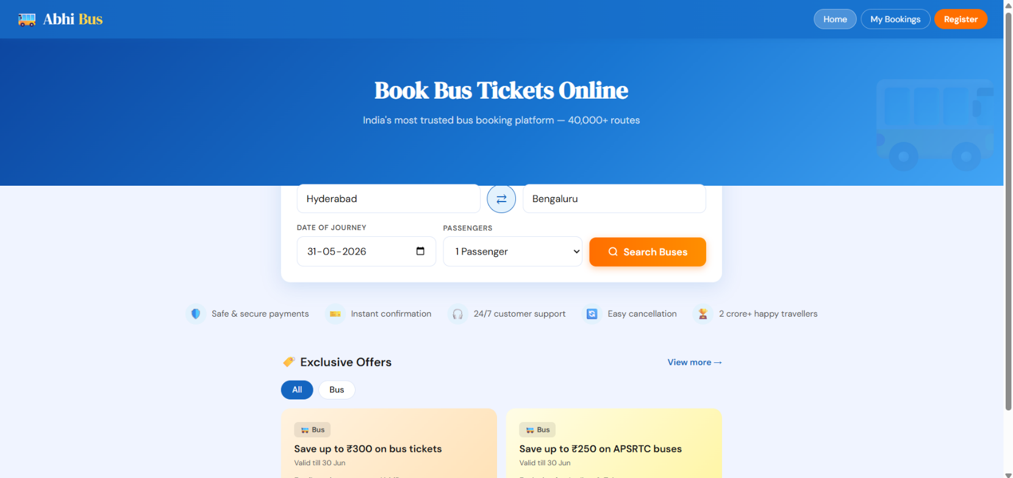

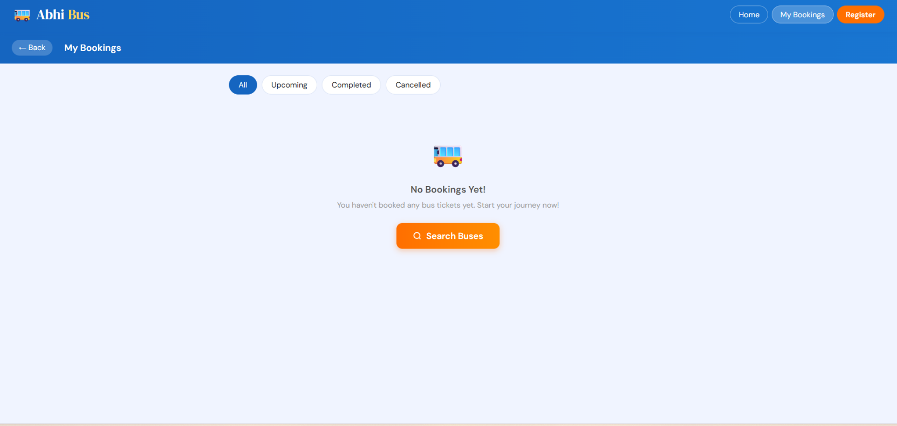
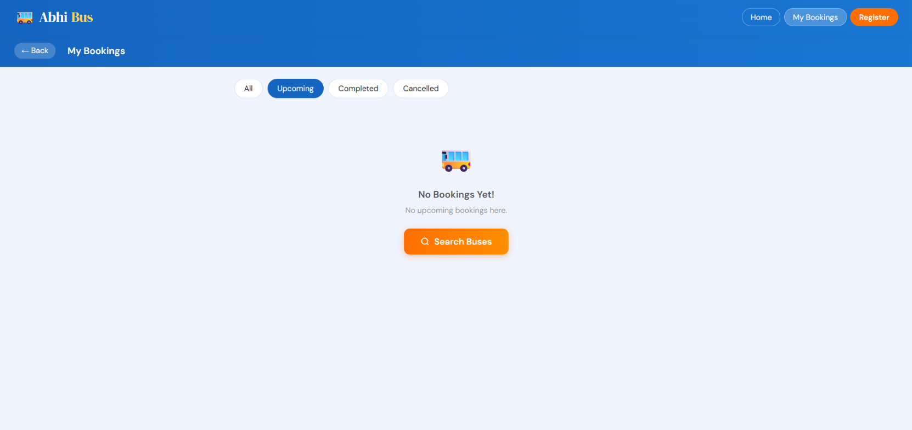
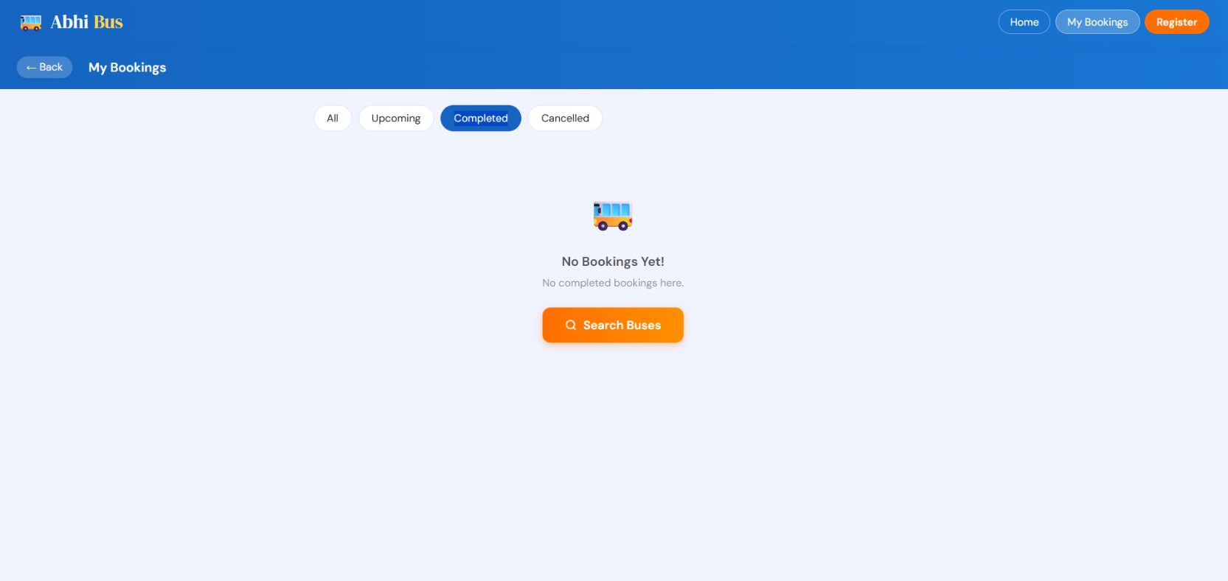
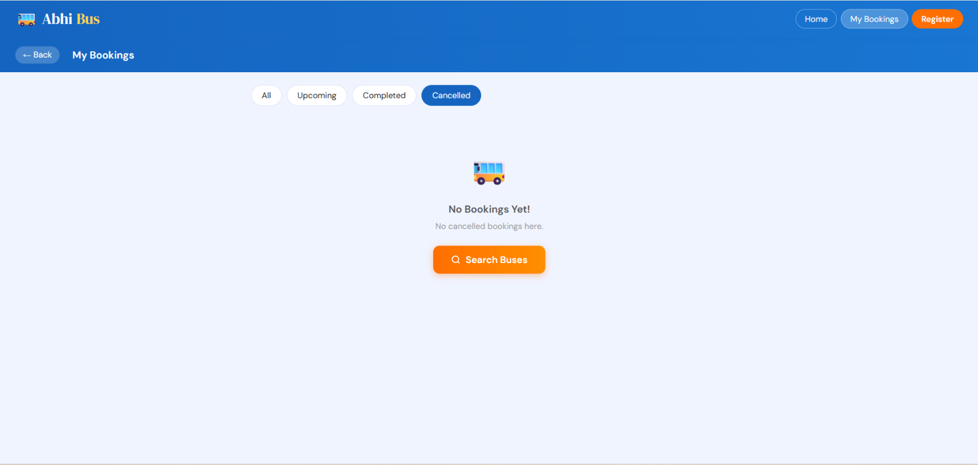
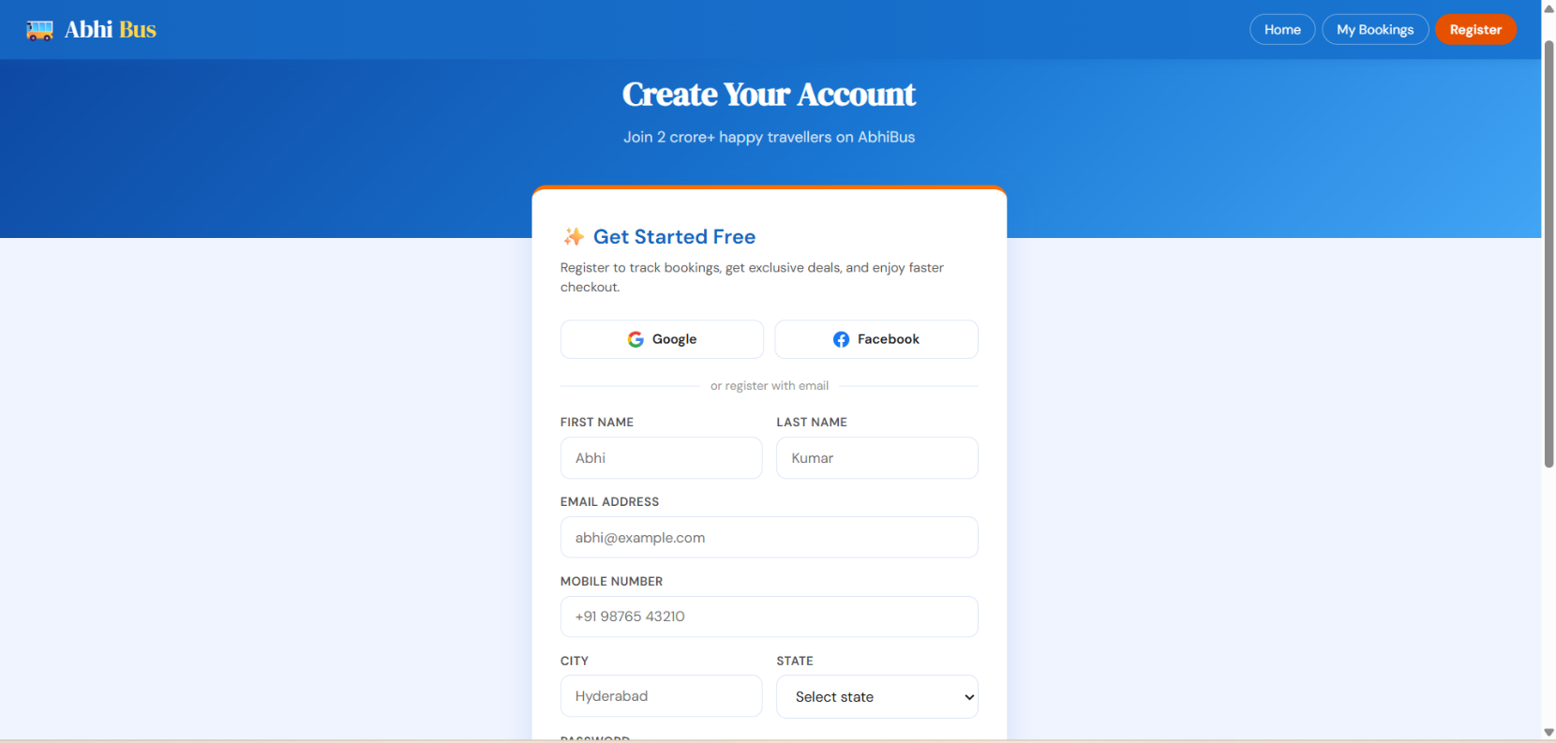

EXPLANATION:
- Developed using HTML and CSS to create an online bus ticket booking interface.
- Features a sticky navigation header with the AbhiBus logo and user navigation buttons.
- Includes a hero section with promotional content and an attractive gradient background.
- Provides a bus search form where users can enter source and destination locations, select travel dates, and choose bus types.
- Contains a swap button to exchange source and destination cities easily.
- Displays a search button for finding available buses.
- Highlights platform benefits through a perks section such as secure booking and customer support.
- Shows bus search results in well-designed cards after a search is performed.
- Displays bus details including operator name, bus type, departure time, arrival time, and journey duration.
- Shows amenities, ratings, seat availability, and ticket prices for each bus.
- Includes filter options to sort buses based on categories like AC, Non-AC, Sleeper, Seater, and Premium.
- Uses operator badges to identify Government, Private, and Premium bus services.
- Provides an interactive seat selection page with upper and lower deck layouts.
- Represents seat statuses such as available, selected, booked, and ladies-only seats using different colors and styles.
- Includes a booking summary panel displaying selected seats, fare details, and booking information.
- Uses CSS Grid and Flexbox for efficient layout management.
- Implements a responsive design that works across desktop, tablet, and mobile devices.
- Applies a modern blue-and-orange color scheme for a professional appearance.
- Incorporates hover effects, animations, rounded corners, and shadows to enhance user experience.
- Simulates a complete bus reservation system, allowing users to search buses, compare options, select seats, and review booking details before payment.
- Displays the total fare amount and booking details in the booking summary section.
- Separates fare information using borders for better readability.
- Provides a button that allows users to proceed with the booking process.
- Includes hover, click, and disabled states for interactive buttons.
- Allows users to select boarding and dropping points through dropdown menus.
- Provides city search suggestions while typing in location fields.
- Highlights matching search terms to improve search experience.
- Displays journey-related statistics using small information chips.
- Shows promotional offers and discounts available to users.
- Allows filtering of offers based on different categories.
- Presents offers in a horizontal carousel format for easy browsing.
- Displays colorful offer cards containing discount details and validity information.
- Shows coupon codes that users can copy and apply during booking.
- Includes carousel navigation buttons and indicator dots for offers.
- Displays booking history in organized card layouts.
- Shows booking status such as Upcoming, Completed, and Cancelled using different colors.
- Provides route information including source, destination, and travel timings.
- Displays additional booking details such as seat information and booking references.
- Offers action buttons for viewing, downloading, or managing tickets.
- Displays a friendly empty-state message when no bookings are available.
- Provides a dedicated registration page for new users.
- Includes input fields for collecting user information during registration.
- Validates form inputs and displays error messages when necessary.
- Allows users to show or hide passwords while entering them.
- Includes a checkbox for accepting terms and conditions.
- Provides a registration button for creating a new account.
- Supports social login and registration options.
- Displays success notifications after completing important actions.
- Includes a password strength indicator to encourage secure passwords.
- Adapts the layout for mobile, tablet, and desktop devices.
- Uses responsive design techniques to improve accessibility across screen sizes.
- Incorporates modern UI elements such as gradients, shadows, animations, and hover effects.
- Maintains a consistent and professional design throughout the bus booking application.
- Displays a navigation header with the AbhiBus logo and menu options such as Home, My Bookings, and Register.
- Allows users to navigate between different pages of the application using navigation buttons.
- Provides a homepage banner with a bus ticket booking tagline and promotional message.
- Includes a bus search form where users can enter departure and destination cities.
- Supports city auto-suggestions while typing through a searchable dropdown list.
- Allows users to swap source and destination cities using a swap button.
- Provides date selection for choosing the journey date.
- Includes a passenger selection dropdown supporting multiple passenger counts.
- Offers a Search Buses button to view available bus services.
- Highlights platform benefits such as secure payments, instant confirmation, customer support, easy cancellation, and a large customer base.
- Displays exclusive promotional offers and discounts for bus bookings.
- Provides offer category filters to view specific types of offers.
- Shows discount cards containing offer titles, validity dates, descriptions, and coupon codes.
- Allows users to copy coupon codes directly from offer cards.
- Uses a carousel interface with navigation arrows and indicator dots to browse offers.
- Displays search results with route information, travel date, and total available buses.
- Provides bus filtering options such as AC, Non-AC, Sleeper, Seater, Government Buses, and Night Services.
- Lists available buses dynamically with detailed travel information.
- Displays a dedicated seat selection page for selected buses.
- Shows bus name, route details, travel duration, and ticket pricing information.
- Provides separate lower-deck and upper-deck seat layouts.
- Uses visual indicators to identify available, selected, booked, and ladies-only seats.
- Displays a booking summary containing selected seats, fare, convenience fees, and total amount.
- Enables users to proceed with booking only after selecting seats.
- Allows users to choose boarding and dropping points from predefined options.
- Includes a My Bookings page for viewing booking history.
- Provides filters to view all, upcoming, completed, or cancelled bookings.
- Includes a registration page for new users.
- Allows registration using Google and Facebook social login options.
- Provides a registration form with fields for personal and contact information.
- Includes city and state selection fields during account creation.
- Supports password creation with password strength checking.
- Allows users to show or hide passwords using a visibility toggle.
- Includes confirm password validation to ensure matching passwords.
- Displays validation messages for incorrect or incomplete form inputs.
- Requires users to accept terms and conditions before registration.
- Provides a Create My Account button to complete registration.
- Displays a success notification after successful account creation.
- Includes a sign-in link for existing users.
- Stores a large list of Indian cities and states for location suggestions.
- Maintains a collection of promotional offers with coupon codes and discount information.
- Contains detailed bus data including operator names, bus types, amenities, ratings, fares, and seat availability.
- Supports government, private, and premium bus operators through categorized data.
- Includes JavaScript functions for city search, city selection, dropdown management, offer filtering, coupon copying, carousel navigation, and page interactions.
- Uses dynamic rendering techniques to update offers, search results, and booking information without reloading the page.
- Creates a complete front-end simulation of an online bus ticket booking and reservation platform similar to AbhiBus.
- Responsive bus ticket booking application with multi-page navigation (Home, Search Results, Seat Selection, My Bookings, Registration).
- Dynamic city search with autocomplete suggestions and route swapping functionality.
- Bus search based on source, destination, journey date, and passenger count.
- Real-time bus filtering by AC, Non-AC, Sleeper, Seater, Government, and Night services.
- Interactive bus listing with ratings, amenities, pricing, seat availability, and operator categories.
- Detailed seat selection system with lower deck and upper deck layouts.
- Visual seat status indicators for available, selected, booked, and ladies-only seats.
- Maximum seat selection limit validation for better booking control.
- Automatic fare calculation including convenience fees and total amount updates.
- Boarding and dropping point selection before booking confirmation.
- Dynamic booking summary displaying selected seats and total fare.
- Offer and coupon management section with category filters and copy-to-clipboard functionality.
- Responsive carousel for promotional offers with navigation controls.
- My Bookings module with Upcoming, Completed, and Cancelled booking filters.
- Empty-state handling for users without booking history.
- User registration page with social login options and email registration.
- Form validation for name, email, mobile number, password, and confirm password fields.
- Password strength indicator with live feedback.
- Show/Hide password functionality for improved user experience.
- Terms and conditions acceptance validation before account creation.
- Success notification after successful registration.
- Mobile-friendly and user-friendly interface with modern UI components.
- Built using HTML, CSS, and JavaScript with DOM manipulation and event-driven functionality.
- Modular data management using arrays and objects for cities, buses, offers, and bookings.
- Dynamic rendering of search results, offers, seat layouts, and booking records without page reloads.
- Interactive user experience with real-time updates, validations, and booking workflows.

